Designing and Implementing a Thread-Safe Banking System

Module: Advanced Object-Oriented Design and Programming
Unit 6: Concurrency and Parallelism in Object-Oriented Design
Supervisor: Dr Nawaz Khan

Contents
1. Introduction 1
2. Design and Class Structure 2
2.1 The BankAccount Class 2
3. The TransactionSimulator Class 4
4. Ensuring Thread Safety 5
5. Deadlock Prevention in Transfers 6
6. Transaction Simulation 7
7. Testing and Validation 9
7.1 Single-Operation Tests 10
7.2 Concurrent Tests 11
8. Conclusion 12
References 13
Appendix 13

Introduction

This assignment provides the design and implementation of a thread-safe banking system, which allows multiple users to perform transactions concurrently. The proposed system supports key banking operations, including depositing, withdrawing, checking the account balance, and transferring money between different accounts. Since multiple customers may access the same account at the same time, the proposed system should be design efficiently to protect the data shared between different accounts. Besides, the proposed system should also prevent concurrency problems such as race conditions and deadlocks. Therefore, this assignment builds a banking system in which calculations remain accurate and predictable, regardless of how many users interact with it simultaneously.
The proposed banking system is implemented in Python using the standard threading module. The BankAccount class represents an individual bank account and handles thread safety internally. The TransactionSimulator class simulates several users carrying out transactions at the same time.
The program begins by importing the two standard-library modules as:
Import threading
Import time

Design and Class Structure

The proposed system is organised around two separate responsibilities. The BankAccount class is responsible for storing the account information and safely updating it. The TransactionSimulator class is responsible for running transactions concurrently. The rules that keep the account safe are handled within the BankAccount class.

The BankAccount Class

Each account is created using a constructor that takes an account_number and an initial balance. The account number is used as a unique identifier. The balance shows the amount of money available in the account.
Every account creates its own lock when it is created. The lock has been implemented using threading.Lock(). Since the lock is stored as an instance attribute, every account has its own lock. This allows different accounts to be used at the same time without waiting between threads.
One of the key features in object-oriented programming is to set up an object's initial state, which can depend on the language (Othman et al., 2025).
An example of constructor that generate the account number is shown below:
class BankAccount:
def __init__(self, account_number, balance):
self.account_number = account_number
self.balance = balance
self.lock = threading.Lock()

Three main methods have been used to provide the required functionality. The deposit(amount) method adds a positive amount to the account balance. The withdraw(amount) method deducts money from the balance when enough funds are available. The get_balance() method returns the current balance.
The deposit() method includes a guard condition that rejects zero or negative amounts. Similarly, the withdraw() method checks whether the requested amount is available in the account. This prevents the account from being overdrawn.
The three methods are shown below:
def deposit(self, amount):
with self.lock:
if amount > 0:
self.balance += amount
def withdraw(self, amount):
with self.lock:
if amount <= self.balance:
self.balance -= amount
def get_balance(self):
with self.lock:
return self.balance

The TransactionSimulator Class

The TransactionSimulator class has been created to simulate the activity of different users. It is constructed with a reference to a single account.
The user_transactions(user_name) method represents the activity of one user. It performs a repeated sequence of deposits and withdrawals. Short calls to time.sleep() have been added to create realistic processing delays.
These delays also allow different threads to run between operations. This creates more opportunities for race conditions to occur. As a result, the simulation provides a more demanding test of thread safety than running the operations one after another.
The function used in this class can be defined as follows:
class TransactionSimulator:
def __init__(self, account):
self.account = account
def user_transactions(self, user_name):
for i in range(2):
# Simulate some processing time
time.sleep(2)
self.account.deposit(50)
print(f"{user_name} Deposited successfully £50")
time.sleep(1.5)
self.account.withdraw(20)
print(f"{user_name} Withdrew successfully £20")
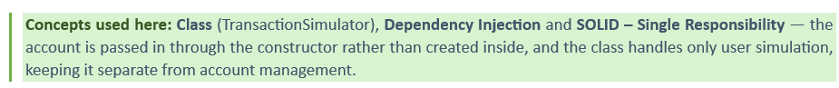

Ensuring Thread Safety
A race condition is creating a program that depends on the order of the threads to make the function works correctly. In the case of balance updating, this is not an atomic operation, as it involves reading a value, adding some amount to that value, and then writing that new value. However, if two threads read the same balance before either one is updated, one of the changes can be lost. Therefore, managing shared state safely across multiple threads is a central concern of concurrent programming in Python (Nguyen, 2022). To prevent this happening, every operation that reads or changes the balance needs to be protected by a mutual-exclusion lock.
In Python, the implementation of context-manager syntax is accomplish using `self.lock`. The lock is obtained when a critical section starts and automatically released when the section ends. This represents a safer approach compared to the manual use of `acquire()` and `release()` as the lock will still be released if an exception occurs inside the block.
As shown in the `deposit()`, `withdraw()`, and `get_balance()` methods in Section 2.1, every access to the balance has been placed inside this protected section. This means only a single thread can hold the lock at a time. Other threads have to wait until the lock is available again, which controls access to the shared balance. This ensures that updates are not lost when multiple threads are running at the same time.
The lock has been placed inside the account object rather than in the code that use it. This is a deliberate design choice. It means that the protection stays with the data it is responsible for. External code does not have to manage the lock itself.
This approach also reduces the chance of synchronisation being forgotten. The shared data and the mechanism that protects it have been kept together within the same class.

Deadlock Prevention in Transfers

A common concurrency problem can arise when transferring money between two accounts. A transfer requires locking both the source and destination accounts. Therefore, this ensures that the funds are moved safely as one operation.
If two threads try to transfer money between the same accounts at the same time, a deadlock needs to occur. For instance, one thread may lock account A and then wait for account B. At the same time, another thread may lock account B and wait for account A. Neither thread can continue because each one is waiting for a lock held by the other. This creates a circular wait and can cause the affected threads to remain blocked. Therefore, the proposed system is designed to prevent this type of deadlock by using a consistent order when acquiring locks. Inside the transfer method, the two accounts are compared using their account numbers. Each account with a higher account number has its lock acquired first. The lock for the other account is then acquired. Every transfer follows the same ordering rule. This means that a circular wait cannot be created. If two threads are transferring money between the same pair of accounts, they will request the locks in the same order. One thread will wait for the other to finish instead of becoming permanently blocked. The method is implemented as follows:
def transfer(self, account1, amount):
if self.account_number > account1.account_number:
first = self
second = account1
else:
first = account1
second = self
with first.lock:
with second.lock:
if amount > 0 and amount <= self.balance:
self.balance -= amount
account1.balance += amount

Transaction Simulation
The main program demonstrates system operation from start to finish. Two accounts are created initially, and a series of simple deposits, withdrawals, and transfer are then performed. When only a single thread is used, these operations confirm correct operation of system. Next, the program creates a Transaction Simulator, and four separate threads are launched; each corresponding to a different user. However, all four users perform transactions using the same account and the threads start together to simulate concurrent activity.
The join() method is then used to make the main thread wait until all user threads have finished. The final balance is printed once the threads are completed. The driver code is shown below:
if __name__ == "__main__":
account = BankAccount("SALI93", 2000)
account1 = BankAccount("AWA93", 1000)
account.deposit(1000)
account.withdraw(500)
print("Balance of SLAI93:")
print(account.get_balance())
account.transfer(account1, 500)
print("Balance after transfer:")
print("SALI93:", account.get_balance())
print("AWA93:", account1.get_balance())
simulator = TransactionSimulator(account)
# Create multiple users/threads
thread1 = threading.Thread(
target=simulator.user_transactions, args=("User 1",))
thread2 = threading.Thread(
target=simulator.user_transactions, args=("User 2",))
thread3 = threading.Thread(
target=simulator.user_transactions, args=("User 3",))
thread4 = threading.Thread(
target=simulator.user_transactions, args=("User 4",))
# Start the threads
thread1.start()
thread2.start()
thread3.start()
thread4.start()
# Wait for all threads to finish
thread1.join()
thread2.join()
thread3.join()
thread4.join()
# Display the final balance
print("Final Balance:")
print(account.get_balance())
The used concepts here are: Object creation (account = BankAccount(...)), Concurrency through four threading. Thread objects run with start(), and Race Conditions are prevented because every threaded operation goes through the locked methods before the final balance is read.
This design is important as it directly tests the system's concurrency control. Four users have been set up to deposit and withdraw money from the same account at the same time. Each user has a fixed set of operations, so the expected final balance can be calculated before the program is run. This facilitates comparing the expected result with the actual balance and check whether the thread-safety mechanisms are working correctly.
After executing the program, the expected behaviour was confirmed when initial deposit and withdrawal produced a balance of £2500. After a £500 transfer, the sender's balance reduced to £2000, and the receiver's balance was £1500. The four users’ threads then performed their transactions in an interleaved order, which demonstrates the concurrent threads running.
The program ends with a final balance of £2240, which is correct as explained below: Starting with £2000 after the transfer, each user completed two rounds of £50 deposits followed by a £20 withdrawal. This gives a net increase of £30 per round. With four users completing two rounds, the total increase was £240, giving a final balance of £2240.
The order of the printed messages changed between runs, but the final balance remained the same. This provides strong evidence that the locking mechanism has prevented lost updates and kept the shared balance consistent during concurrent execution.

Testing and Validation

To validate the proposed system, a dedicated test suite is written using Python's built-in unit test framework in a separate file. Keeping the tests apart from the implementation is useful practice, because it allows the automated checks to be run repeatedly without altering the production code. The suite imports the BankAccount class and defines a test case class, TestBankAccount, whose methods each verify one aspect of the system using assertions. An assertion states the result the code is expected to produce, and the test fails automatically if the real result differs, which turns validation into an objective, repeatable process rather than a matter of visual inspection.

Single-Operation Tests

The first three tests confirm that the basic operations behave correctly in isolation. The method (test_deposit) adds funds and asserts the new balance, (test_withdraw) removes funds and checks the result, and (test_transfer) moves money between two accounts and asserts that the debited and credited amounts match. Each expected value is known in advance, so (assertEqual) gives a clear pass or fail:
import unittest
import threading
from BankAccount import BankAccount
class TestBankAccount(unittest.TestCase):
def test_deposit(self):
account = BankAccount("SALI93", 2000)
account.deposit(500)
self.assertEqual(account.get_balance(), 2500)
def test_withdraw(self):
account = BankAccount("AWA93", 1000)
account.withdraw(200)
self.assertEqual(account.get_balance(), 800)
def test_transfer(self):
account = BankAccount("SALI93", 2000)
account1 = BankAccount("AWA93", 1000)
account.transfer(account1, 100)
self.assertEqual(account.get_balance(), 1900)
self.assertEqual(account1.get_balance(), 1100)

Concurrent Tests
The two most important tests exercise the system under real concurrency, which is where thread safety matters. To this end the function (test_concurrent_deposits) starts ten threads that each deposit ten pounds ten times, so a correct, race-free implementation must finish with exactly three thousand pounds. Likewise, (test_concurrent_withdraws) starts ten threads that each attempt one hundred withdrawals of ten pounds against a starting balance of five hundred, and asserts a final balance of zero. The following is the function and its use.
def test_concurrent_deposits(self):
account = BankAccount("SALI", 2000)
def deposit_money():
for i in range(10):
account.deposit(10)
threads = []
for i in range(10):
thread = threading.Thread(target=deposit_money)
threads.append(thread)
thread.start()
for thread in threads:
thread.join()
self.assertEqual(account.get_balance(), 3000)
def test_concurrent_withdraws(self):
account = BankAccount("SALI93", 500)
def withdraw_money():
for i in range(100):
account.withdraw(10)
threads = []
for i in range(10):
thread = threading.Thread(target=withdraw_money)
threads.append(thread)
thread.start()
for thread in threads:
thread.join()
self.assertEqual(account.get_balance(), 0)
if __name__ == "__main__":
unittest.main()
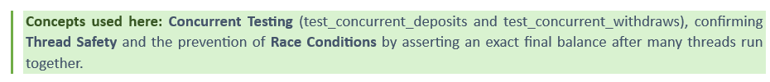
These concurrent tests are a particularly strong form of validation. Because each thread performs a fixed number of operations, the correct final balance can be calculated exactly. Therefore, any lost update caused by a race condition would make the assertion fail. Running the suite with unittest.main() and observing that every test passes provides objective evidence that the locking correctly serialises access, which indicate that the system is thread-safe. When the suite was executed, all five tests passed, with the framework reporting “Ran 5 tests in 0.008s – OK”, confirming that both the single-operation and concurrent scenarios produced their expected balances.

Conclusion
This assignment provided a thread-safe banking system that supports deposits, withdrawals, balance enquiries, and transfers between accounts. A considerable performance evaluation and functions are provided to illustrate the effectiveness of using the proposed system. Among different cases considered, the race conditions have been prevented using account locks, while deadlocks have been avoided by acquiring locks in a consistent order. Evaluation and testing with multiple threads showed that the proposed system can produce the correct final balance as desired.

References
[1] Nguyen, Q. (2022) Advanced Python programming. 2nd edn. Birmingham: Packt Publishing. Available at: https://learning.oreilly.com/library/view/advanced-python-programming/9781801814010/ (Accessed: 15 August 2026).
[2] Othman, J., Mohamed Yusoff, S.A., Rosmani, A.F. and Abu Bakar, M.S. (2025) 'Structural differences of constructor methods in object-oriented paradigms: a comparative study using C++, Java and Python', Beyond Boundaries: The Multidimensional Horizons of E-Learning, 9, pp. 165–170.

Appendix
Attached are the bank account code, which is implemented to be thread-safe, and the unit test code in a separate file.
- Bank Account Code
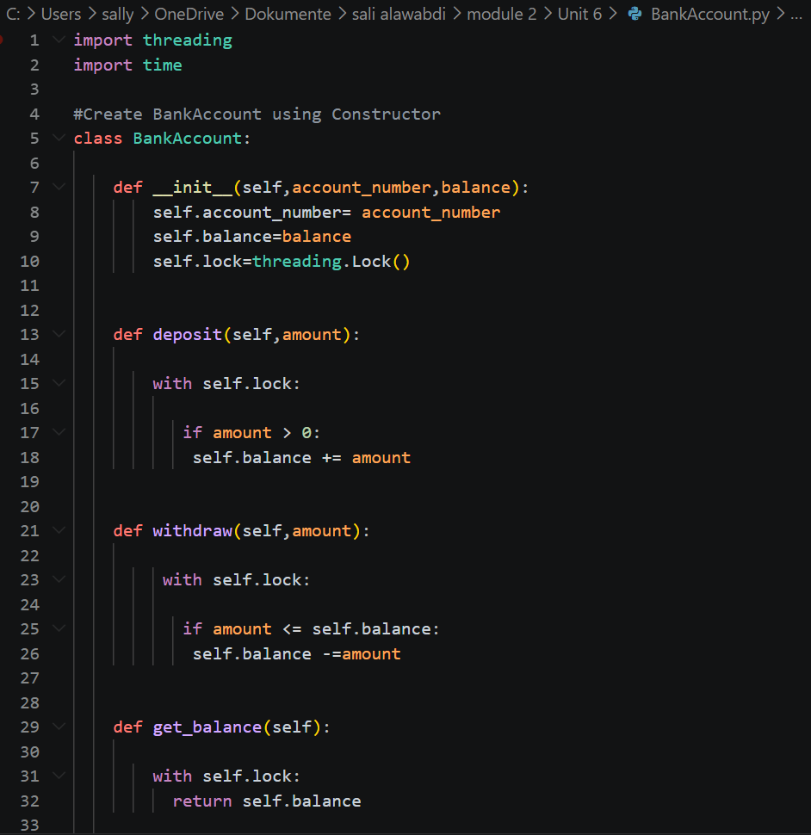
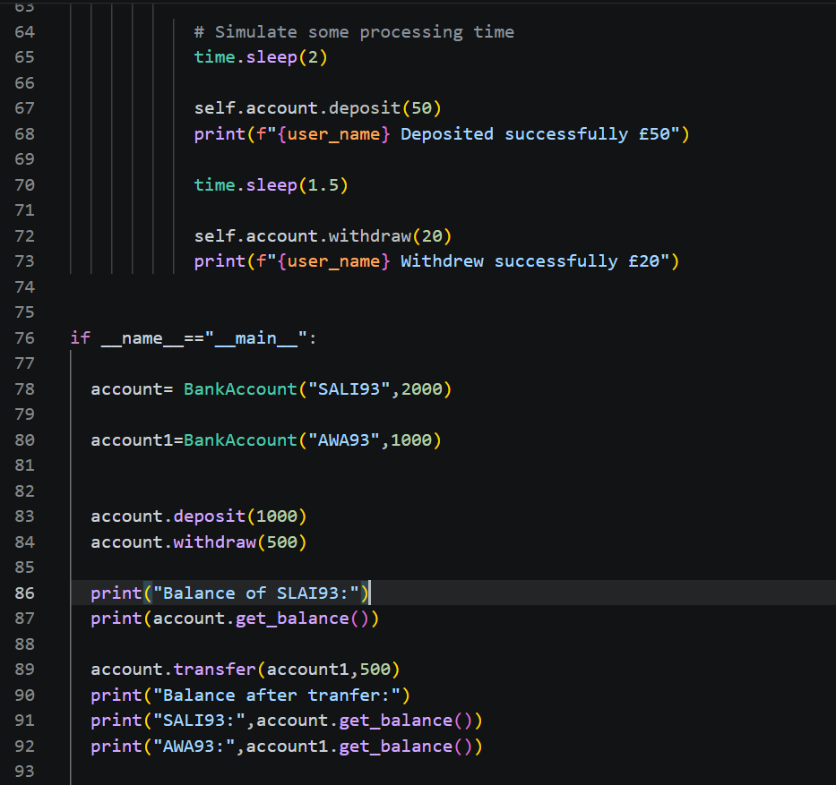
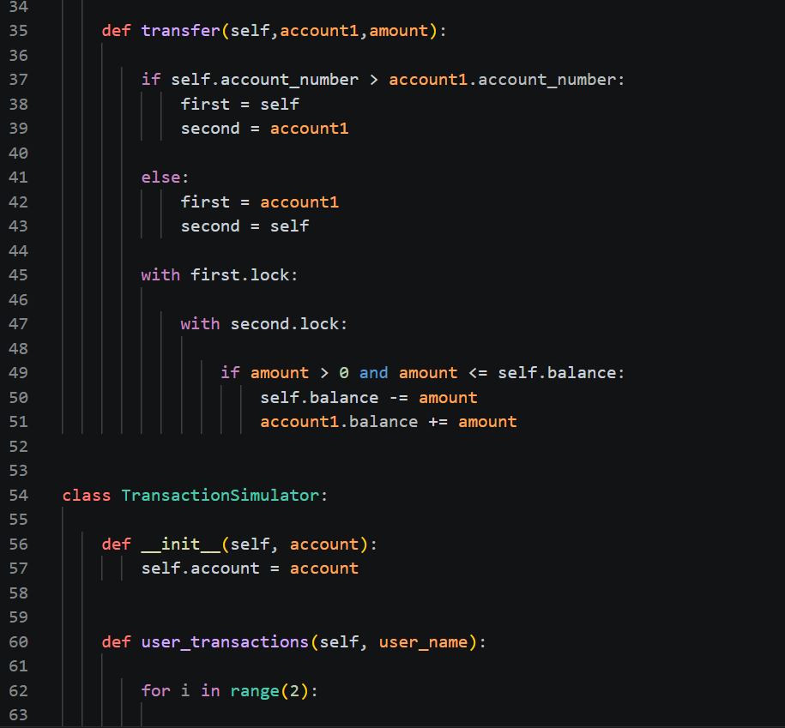

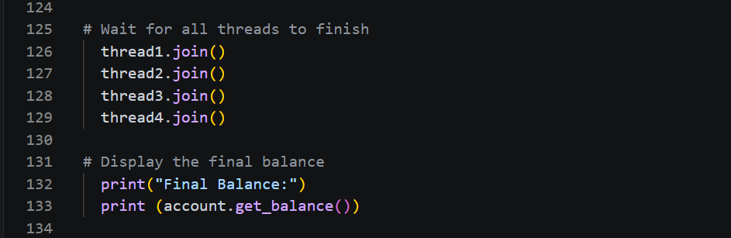
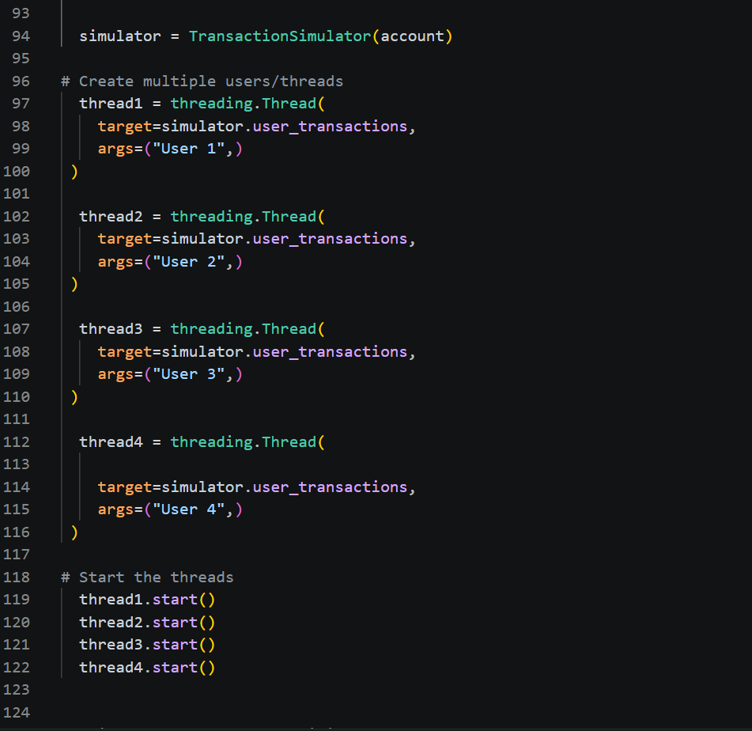

- Unit Test Code
